7.13.5 Print Invoice Switch Maintenance
We use this function to uncofirm the invoice when we need to change something in there (to correct/add the comment, change the price,..)
It works just for unposted invoice!

Invoice Number: put invoice number + Next
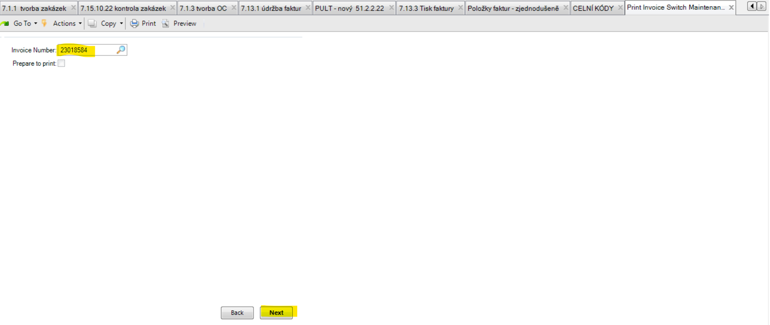

Prepare to print: click the box + Next and thats´ it
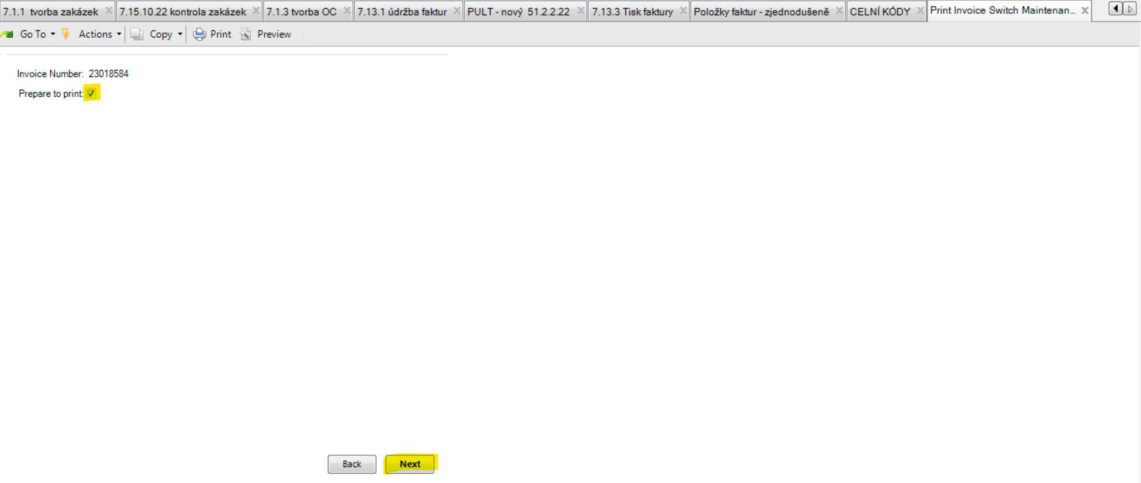

You can check if the invoice is uncofirmed in 51.2.2.22.
Then you can make the changes in the invoice via 7.13.1 and then to invoice it again in 7.13.3.

